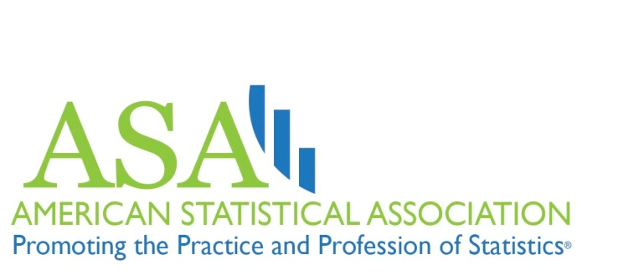

This is Statistics Promotional Toolkit

A Useful Resource for ASA Chapters, Sections and Members
The American Statistical Association (ASA) has developed this promotional toolkit for its chapters, sections and individual members to use to share the messages of its “This is Statistics” public awareness campaign with local audiences. The ASA campaign is educating high school and college students about career opportunities in the field of statistical science.
Many ASA members, particularly in the local chapters, have asked for ways to contribute to the campaign. We’re grateful for this interest and support and believe a valuable way for individual members and groups to contribute to the awareness campaign is by speaking to students at local high schools, colleges and universities about why they should consider a degree and a career in statistics.
To aid members in such grassroots-based community outreach activities, the ASA has prepared the following materials in this toolkit for their use:
- PowerPoint Presentation that speakers can use to show how exciting and important the field of statistics is and how it has grown in recent years. The presentation, titled “Statistics: the Hottest Career of the 21st Century,” features many graphics and images designed to appeal to young people.
- Talking Points for each of the PowerPoint slides that the speaker can use to deliver the PowerPoint presentation. The talking points also can be used as a standalone speech if the speaker does not wish or is not able to use a PowerPoint presentation.
- Video Library that enables speakers to download “This is Statistics” campaign videos onto a thumb drive or laptop in order to show the videos during a speaking engagement.
Produced for the This is Statistics campaign, these videos feature young statisticians explaining why statistics is such a great career choice. This access empowers you to choose the video that best fits your presentation or your audience. (Note: The fifth slide of the PowerPoint presentation features one of the videos. To play this video, you will need an Internet connection during your presentation since the slide is linked to the YouTube page where the video is hosted. If you will not have an Internet connection during your presentation, you will need to download the video from the Video Library onto a thumb drive or laptop in order to play it).
All campaign videos can be downloaded at http://www.amstat.org/misc/tisvideos/ or streamed on-demand at www.youtube.com/ThisIsStats.
- Fact Sheets about careers in statistics that speakers can hand out to students. These one-page and two-page fact sheets feature some of the most important information about careers in statistics and direct the recipient to the campaign website, www.ThisisStatistics.org, for additional information.
Using the Toolkit Resources
ASA members can use these materials to address or introduce students at the college and high school levels to careers in statistics. Following are examples of events or places at which the toolkit resources will help you convey to students information about the many rewarding career opportunities in statistics:
- Speaking engagements—Use the PowerPoint and/or talking points in a speech to a school, class or group of students.
- Career expos—Use the fact sheet handouts and possibly a video at your booth.
- School career days—Use the fact sheets and a video at your table or booth.
- Student career resource centers—Many colleges and high schools have dedicated career counselors and resource centers. Share the fact sheets with them along with the campaign website, www.ThisisStatistics.org.
- Department open houses—Use the fact sheets and a video to connect with attendees.
- Employer information sessions—Many colleges and universities invite employers to visit their schools to speak to students about career fields related to specific degrees. Use the PowerPoint and/or talking points to address students and distribute the fact sheets to attendees.
To learn about such upcoming opportunities in your area or to volunteer to speak to students, contact your local university or high schools. Once you make your first presentation, new opportunities likely will present themselves. Grasp every opportunity you can to share the message about statistics careers.
The ASA is very excited about its This is Statistics campaign and the progress it is making in building awareness of the growth of and exciting career opportunities in statistics. By adding your voice to the campaign, together we’ll carry its messages to more students and build a brighter future for our profession.

